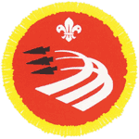

AIR
ACTIVITIES
BADGE


Name:
Six:
Cub Pack:

Section 1: Airfields Can Be Dangerous Places!

1
1

Know the dangers involved in visiting an airfield.
Read the statements below and tick the correct answer.

1. An aeroplane on the ground is taxiing towards you. Should you…?

Run away?
Stand still?
Lie down?

2. You should never drop litter, but why is it especially important not to drop litter on an airfield?

It makes the airfield look untidy.
Rubbish might blow off the airfield into someone’s garden.
Pieces of litter could get sucked into jet engines and damage them.

3. A winch cable, for launching gliders, is lying on the ground. Should you…?

Leave it alone?
Pick it up and practice tying knots with it?
Attach it to something, such as another cub scout?

You are waiting for a helicopter to land. Should you…?

Stand on the spot where it is going to land so that you get a good view?
Run towards it as it descends?
Keep well away and wait for the rotors to stop and the pilot to signal it’s safe before you approach it?
4. A jet aeroplane is standing on the tarmac with its engine running. Where is safe to stand?

In front of the jet intake.
Behind the jet exhaust.
To the side of the aircraft and well clear.
A light aircraft is being serviced in a hangar. Is it safe to…?

Turn the propeller by hand?
Get into the cockpit and try the controls?
Assume that the aircraft is a dangerous place and keep well clear?

You see a red triangle near the cockpit of a jet aeroplane. What does it mean?

Ejector seat.
Don’t climb on the aircraft.
Nothing – it’s just a pretty pattern.

Section 2: Visit an air museum
2
2

By visiting the RAF Museum, Cosford you have completed section 2 of your Air Activities Badge.
Section 3: Activities

For Section 3 you will need to complete 3 activities. There are several to choose from, but this booklet will guide you through 3 (c, e & g) to help you along.

Activity 3c: Parts of an Aeroplane

Fill in the spaces using the words below:

Fuselage – the body of an aeroplane

Wing – the part which supports the aeroplane when flying

Tailplane – small horizontal wing at the tail of the aeroplane

Fin – the upright surface on the tail

Undercarriage – the landing gear and wheels

Cockpit – where the pilot sits

Rudder – hinged rear part of the fin which helps the pilot to steer

Aileron – hinged rear edge of the wing

Elevator – hinged rear part of the tailplane

3
3
If you decide to complete any of the other activities you may find that a visit to the museum shop could help you. There are model aeroplanes, books and pictures which can help you complete the other activities.

3c
3c

Learning about the controls on an aeroplane will help you to get better acquainted with the different parts of the plane.
Find the large model aeroplane in the Fun ‘n’ Flight Interactive Gallery.

Instruction

Model Plane Response
Real Plane Response
Pull control column backwards.

Elevators move up.
The plane climbs.

Push control column forwards.

Elevators move down.
The plane dives.

Push control column left.
Port (left) aileron goes up and the starboard (right) aileron goes down.

The plane banks (tilts) left allowing the pilot to change direction.
Push control column right.
The port aileron goes down and the starboard aileron goes up.

The plane rolls to the right.
Push left pedal forwards.
The rudder moves to the left.

The plane will turn left if it is also banked to the left.
Push right pedal forwards.
The rudder moves to the right.
The plane will turn right if it is also banked to the right.

You can find out more about how aircraft fly by trying the exhibits in the Fun ‘n’ Flight Interactive Gallery. Find examples of different types of aircraft in the museum.

Activity 3e: Identifying Aircraft
3e
3e

Find examples of the different types of aircraft listed below:

Aircraft can be lighter than air or heavier than air.

All flying machines are aircraft.

Aeroplanes use the shape of their wings to obtain lift.

Gliders use rising currents of air to stay up

Helicopters have rotary wings which lift the aircraft by whirling round.

Some aeroplanes have more than one set of wings.
One set of wings is a monoplane.
Two sets of wings is a biplane.

Fill in the name of an aircraft in the Museum that is a:
Airliner e.g. De Havilland Comet
Biplane e.g. Hawker Hind
Monoplane with propeller e.g. Supermarine Spitfire
Twin engined aeroplane e.g. Avro Anson
Jet-propelled aeroplane e.g. MIG 15
Helicopter e.g. Westland Dragonfly
Flying Boat e.g. Consolidated Catalina
Four engined aeroplane e.g. Avro Lincoln
3g
3g
Activity 3g: Weather and Flight

Match each weather condition to the correct statement about flight
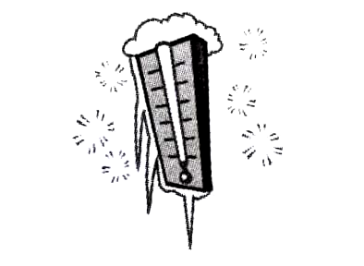
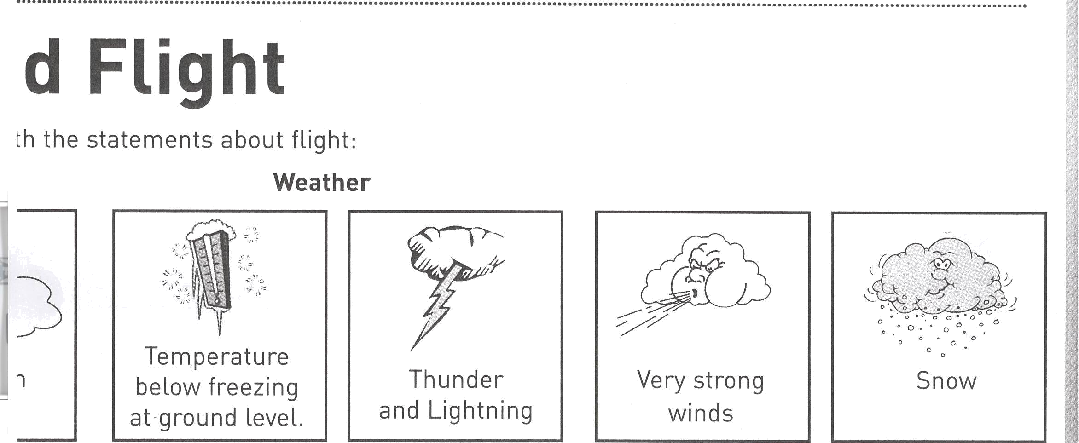
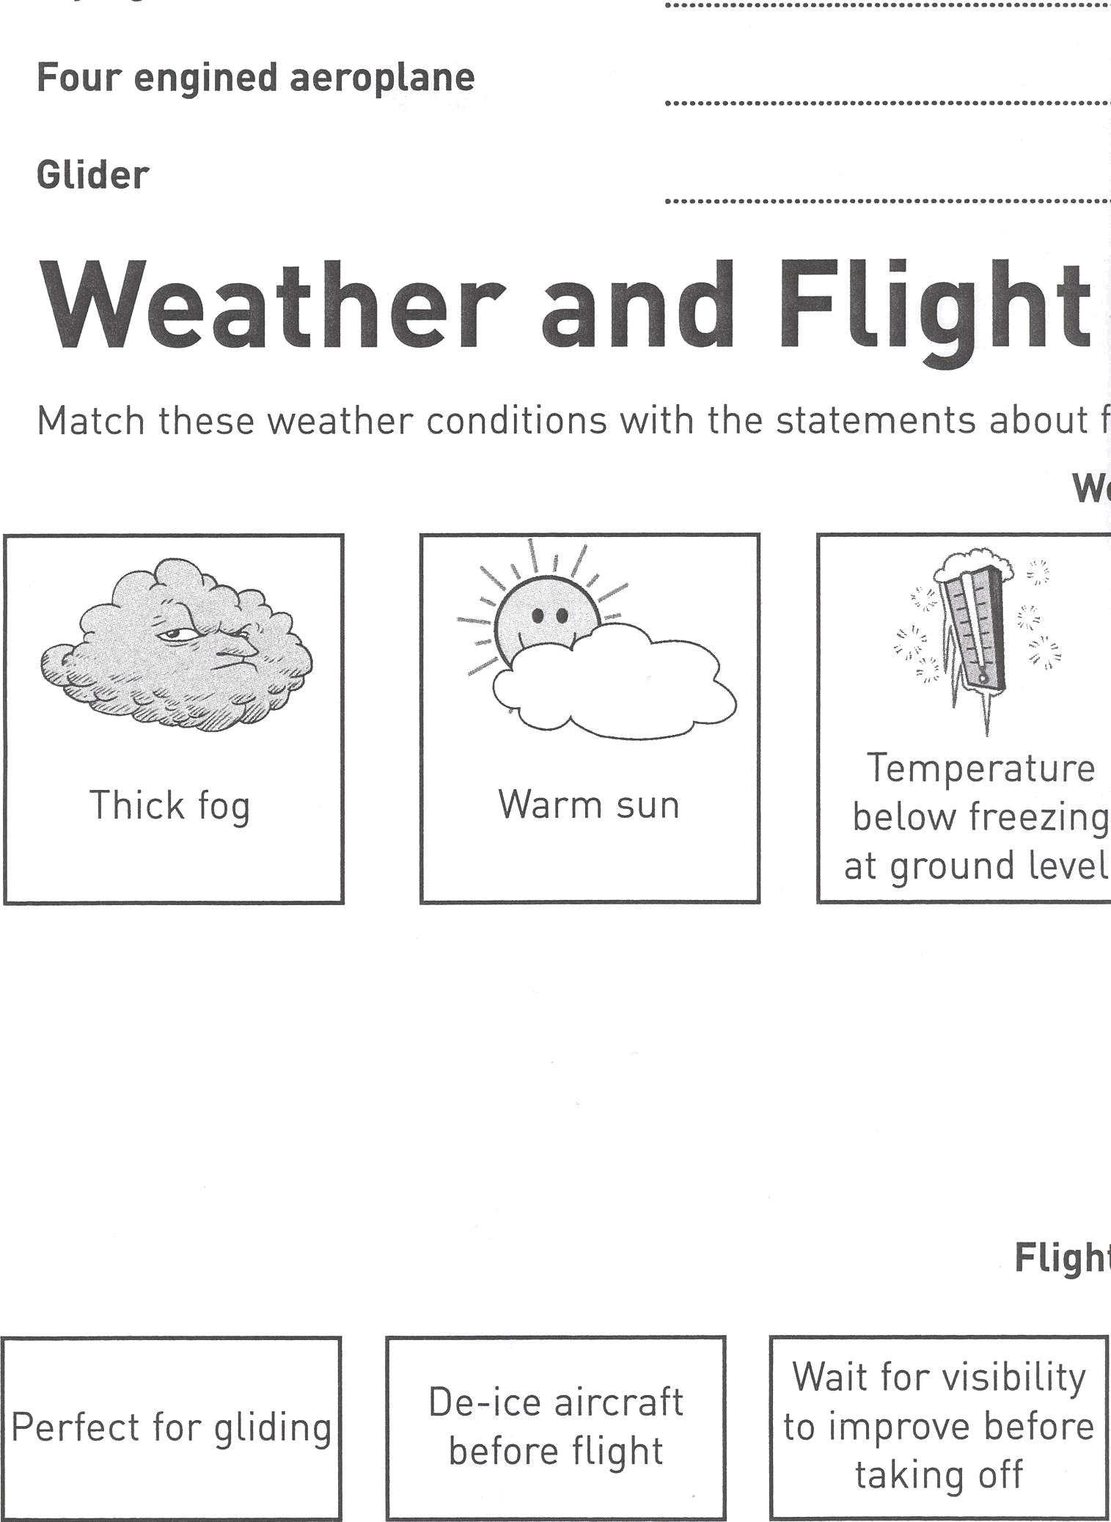
Thick Fog
Temperature below freezing at ground level
Thunder and Lightning
Very Strong Winds
Warm Sun

Snow

De-ice aircraft before flight
Ideal conditions for ballooning
Wait for improved visibility before taking off
Bumpy conditions for flight
Perfect for gliding
Clear runway before aircraft land or take off

