This access statement does not contain personal opinions as to our suitability for those with access needs, but aims to accurately describe the facilities and services that we offer all our guests/visitors.
Access Statement for Royal Air Force Museum Cosford
Introduction
The RAF Museum at Cosford is located in Shropshire in the West Midlands. The nearest town is Albrighton and the Museum is a few minute’s drive from junction 3 on the M54.
The Museum postcode for satnav’s is TF11 8UP. Not all systems recognise this postcode an alternative is WV7 3EU and then follow signs on approach.
Discover the amazing stories of those who have served in the RAF. Housed in our wartime hangars and in the National Cold War Exhibition (NCWE) you will find a fantastic display of aircraft and exhibits. Facilities on site include a cafe, shop, temporary exhibitions and fun ‘n’ flight interactive gallery.
The Museum is open throughout the year and admission is free of charge. For a full site visit please allow a minimum of four hours.
We look forward to welcoming you. If you have any queries or require any assistance please phone 01902 376 200 or email cosford@rafmuseum.org.
Pre-Arrival
- The nearest railway station is at Cosford on the Birmingham to Shrewsbury line. This is a 15-20 minute walk, approximately ½ mile. Cosford is not a manned station and access to platforms is via two flights of steps. Currently there is no provision of lifts.
- The nearest bus stop is on the A41 which is approximately a 1 mile walk from the Museum gates. The road leading to the Museum runs alongside the airfield and there is no footpath.

Car Parking and Arrival
- There is ample pay and display parking at the Museum. On arrival please use Car Park 1 which is closest to the Museum entrance and includes 12 accessible spaces and 6 family spaces. Additional spaces are available on the overflow NCWE car park at peak times.
- The main car parks are on a slight gradient with tarmac surface and lighting is provided. The footpath from the car park to the Visitor Centre/entrance is on a slope and the surface is slabbed. There are no kerbs on entering the building and entry is via two wide automatic sliding doors.
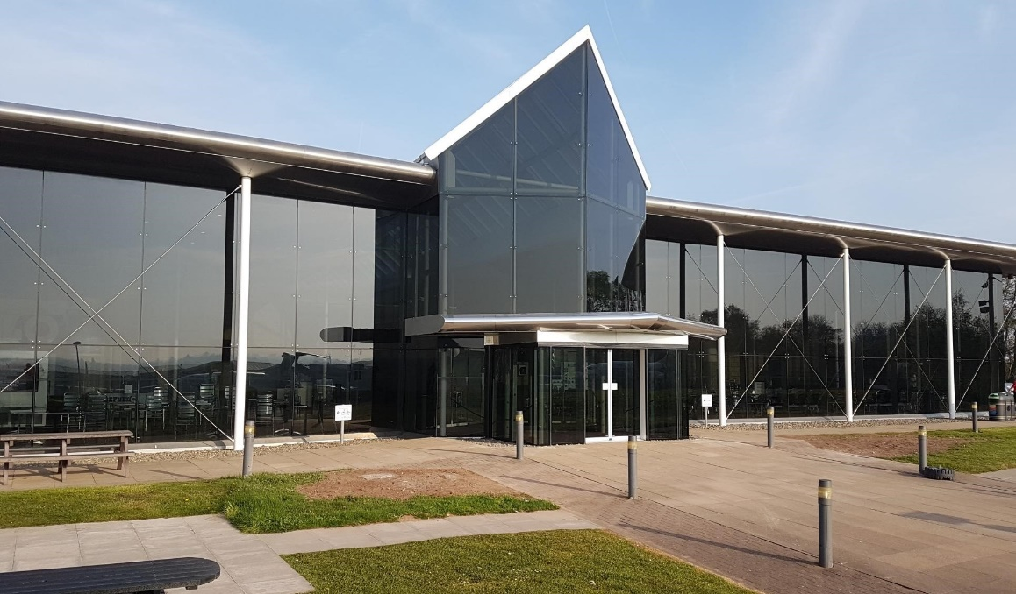
Main Entrance, Reception and Ticketing Area
- There are front of house staff in the Visitor Centre and hangars. They are identifiable through branded red uniforms and name badges. The Visitor Centre is all on one level and accessible toilet facilities are available.
- The building is glass fronted and lighting levels are excellent. An open plan layout means that staff are not positioned behind high desks. There is ample seating in this building which also includes the cafe.
- The floor surface is wood and a limited number of wheelchairs and motor scooters are available for loan on a first come first served basis. There is no charge for this service but donations are welcome.
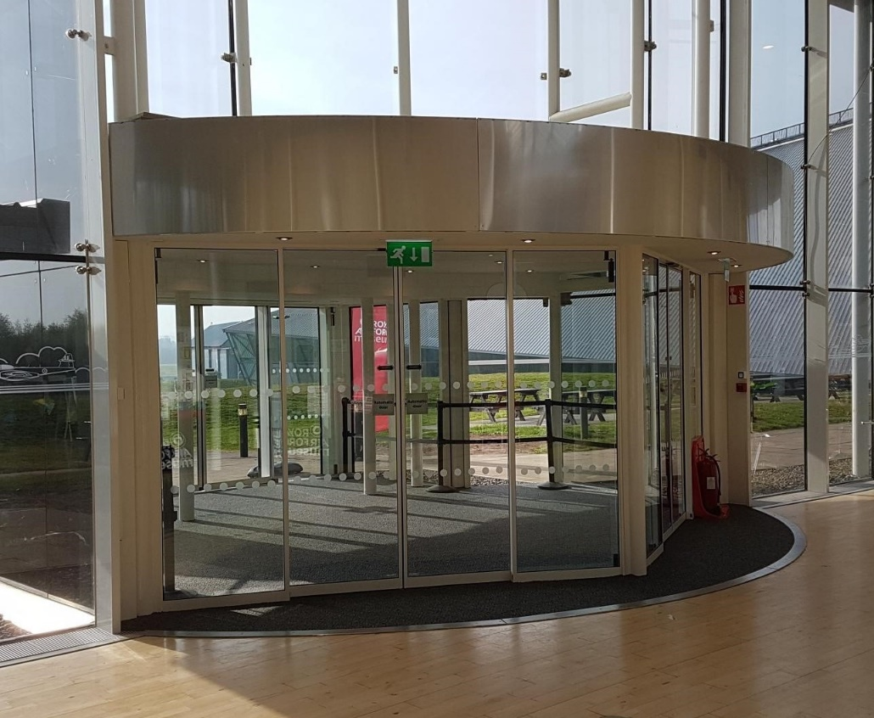
Attraction (displays, exhibits, rides etc.)
- Interpretation on site includes images, videos, panels, 3D objects and touch screen kiosks. Low level barriers ensure good views of exhibits, and are red in colour. Seating is available in all buildings and floor surfaces are predominantly concrete.
- The NCWE is on two levels and there is a lift at one end of the building and an accessible platform lift which holds two people at the other end. Direct entry/exit is also possible on each level of the building.
- All buildings are heated and lighting is in place by exhibits. There is low level lighting in the First World War in the Air exhibition entrance. This exhibition also has a tactile panel for aircraft manufacturing materials. Access to Hangar 1 from the NCWE is via a slope and involves crossing a small road, a pedestrian crossing point is in place.
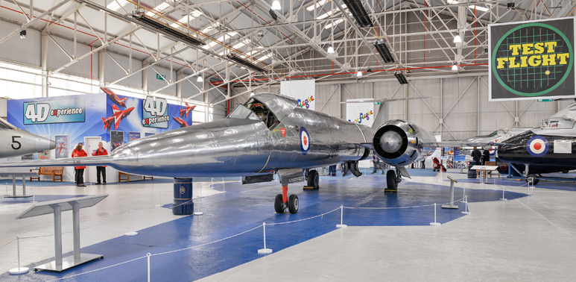
Toilets
- Accessible toilets are located in each of the main museum buildings. Red cord alarms are included in each of the toilets and during opening hours members of staff are present in each hangar.
- There are bins in all toilets and sinks are operated by lever systems or auto-sensor taps.
Catering
- The Cafe is located in the Visitor Centre and is an open plan area with access via the main entrance. Seating is at tables (mostly central pedestal) with light weight chairs and there is ample space. There are also outdoor picnic benches which are suitable for wheelchair access. The Visitor Centre is a glass fronted well lit building. The cafe is self-service with hot food being ordered and bought to the table once prepared. In the National Cold War Exhibition there is a small cafe area with refreshments served from a Citroen H van. Drinks and snacks are served in this area.
- Dietary needs are catered for on request.
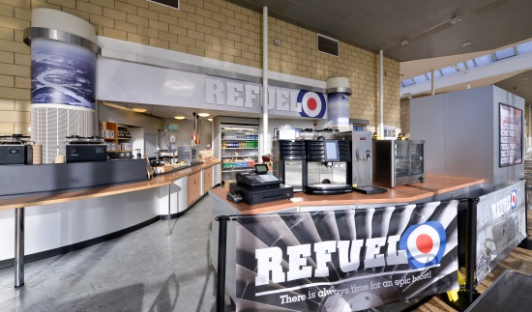
Shop(s)
- The souvenir shop is located on the lower level of the NCWE near the exit to Hangar 1. Access is via the NCWE lift or the return route from H1 which has an automatic sliding door.
- The shop is all on one level and is carpeted throughout. Display racks are at varying heights and there is ample space in the aisles.
- In the Visitor Centre there is a small shop area with a limited range of souvenirs on sale.
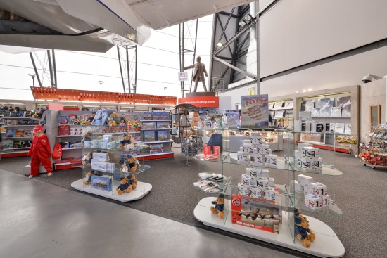
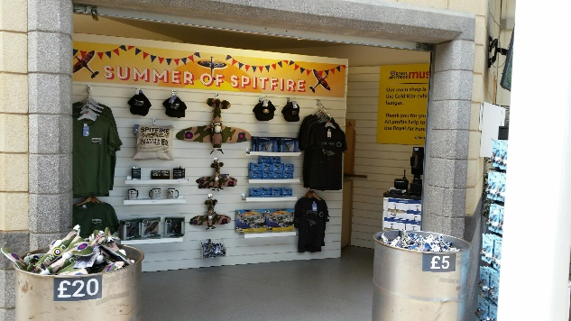
Additional Information
- There are eight aircraft displayed outside in the museum grounds. Close viewing of the Hercules and VC10 aircraft are via a grass matted area. Visitors with Assistance dogs (and those in training) are welcome on site and in museum buildings. Guided Tours for visually impaired visitors can be pre-booked and these are run by volunteers.
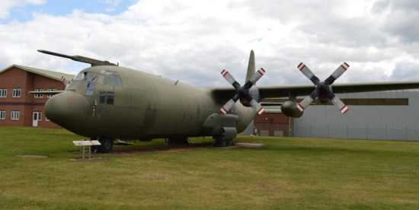

Contact Information
Address (Inc postcode): | Cosford Shifnal Shropshire TF11 8UP
Telephone: | 01902 376 200
Email: | cosford@rafmuseum.org
Website: | rafmuseum.org/cosford
Hours Of Operation: | Open daily from 10.00am

