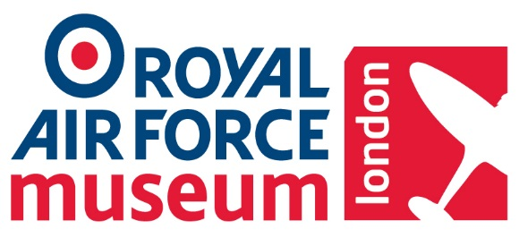
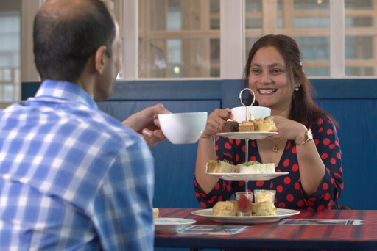

AFTERNOON CREAM TEA MENU

(Available Monday – Sunday between 12.00 – 16.00)
All refreshments served to your table in Claude’s Restaurant

Please choose a selection from the options below:

£25.50 for two people Yes No - Numbers ________

£29.00 for two people with prosecco Yes No - Numbers ________
(min of 4 guests, less than 4 will incur an additional charge. Please enquire within)

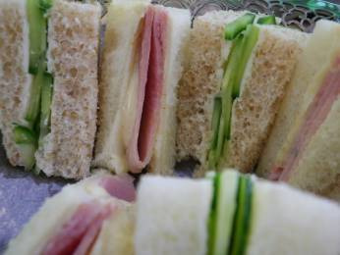
Smoked Scottish Salmon on Granary Bread
Egg & Mustard Cress Mayonnaise on Soft White Bread
Cream Cheese & Cucumber on White Bread
Selection of Homemade Bite Sized Cakes
Scones with Jam & Clotted Cream
A Selection of Teas & Infusions
ENHANCEMENTS - £3.99 PER ITEM
Handmade Scotch Egg Quantity ____
Homemade Sausage Roll Quantity ____
Caramelised Goats Cheese Tart Quantity ____
Marinated Chicken Skewers with Oriental Dipping Sauce Quantity ____

PLEASE NOTE, YOUR CHOICE OF MEALS MUST BE SELECTED 7 DAYS PRIOR TO THE VISIT

An invoice for the package will be sent to you after the visit

Menu valid until 30 September 2019

Please take a copy of this form before returning it to the Museum

Form can be posted or emailed to the Museum. Details below:

Contact: Anji Patel / Odette Harris, Visitor Experience Administrators
Royal Air Force Museum, Grahame Park Way, London, NW9 5LL
T: 020 8358 4849 E: groups@rafmuseum.org
www.rafmuseum.org
